NAME :- OJUS P. JAISWAL

ROLL NO. :- TACO19108

YEAR AND DIV :- TE A

COMPUTER NETWORKS AND

SECURITY LABORATORY

Group C

Assignment No. 17

Ques :- To study the IPsec (ESP and AH) protocol by capturing the packets using Wireshark tool.

Solution :-

1. ESP :

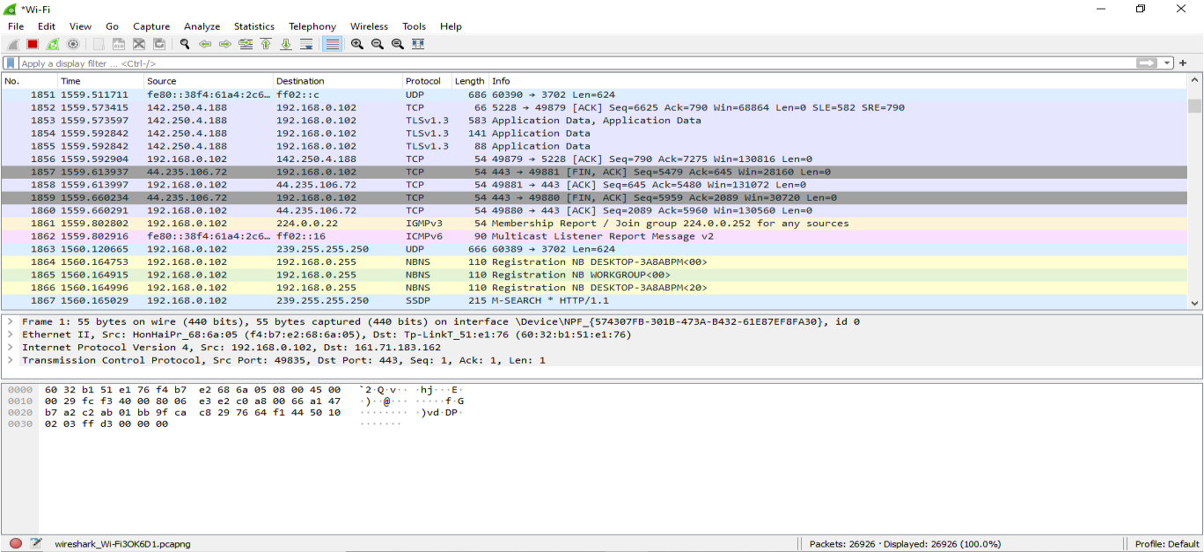

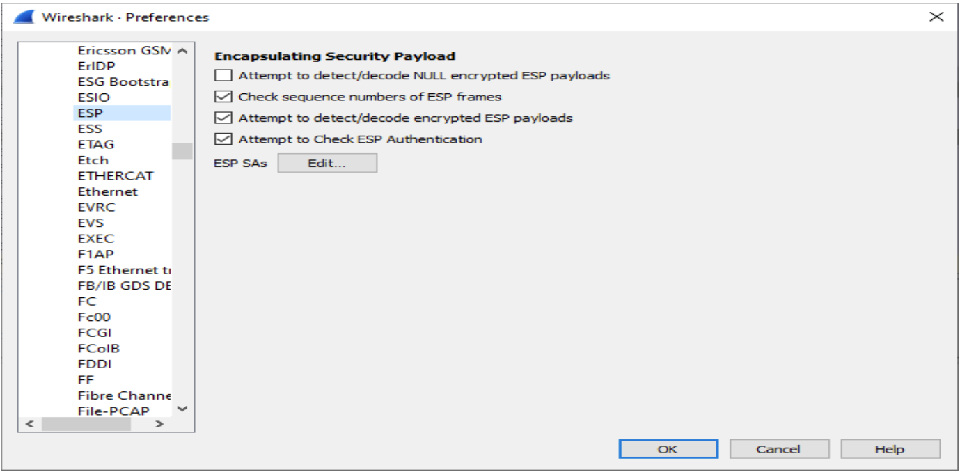

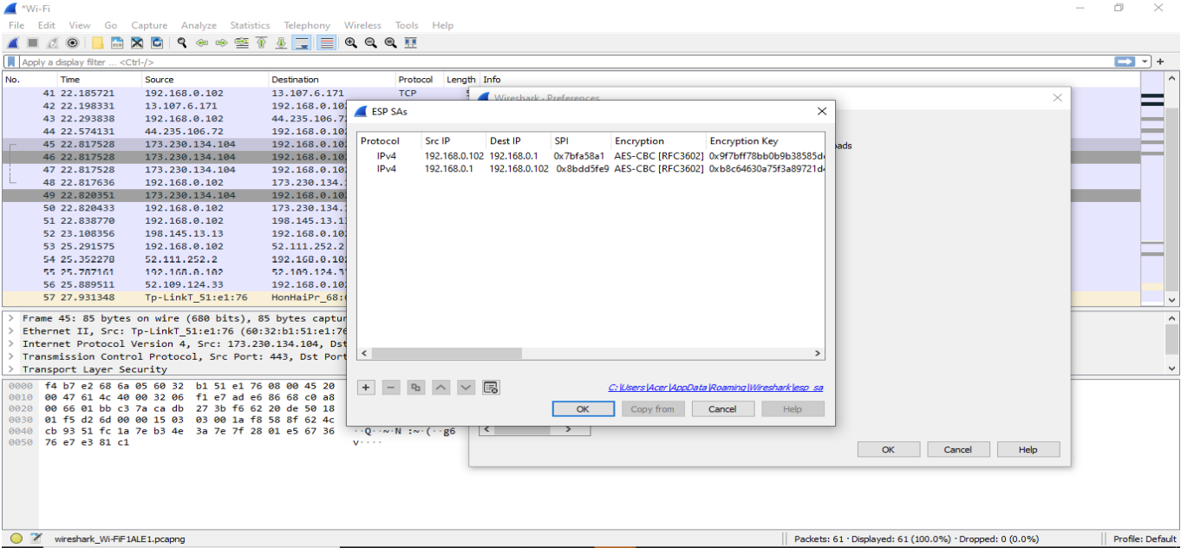

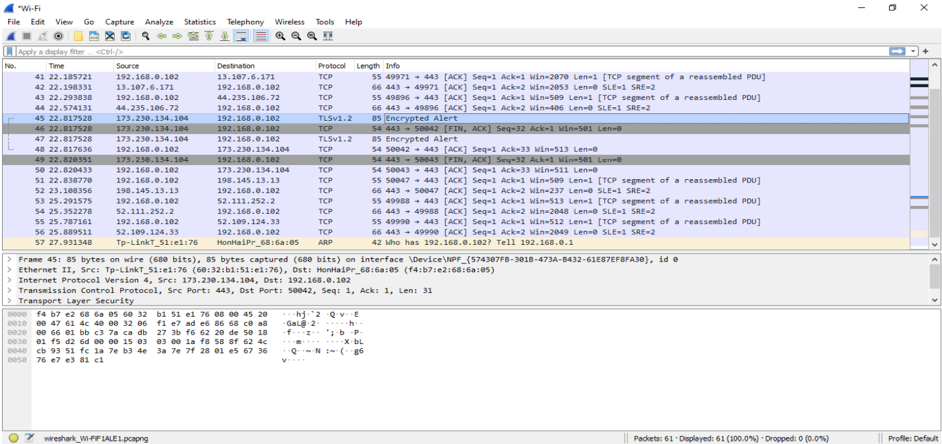

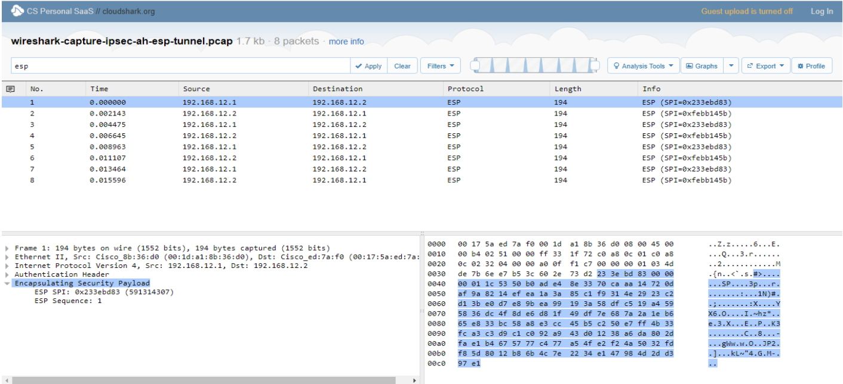

1. AH :

